Digital: Digital Production, Design and Development
T Level outline content: final version for Inclusion in ITT
August 2018
Contents
Introduction | 3
Outline content for T Levels:
Core Content | 7
Occupational specialist content:  - Digital Production, Design and Development | 13

English, Maths and Digital Skills 21

Introduction
T Levels are new, two-year, technical study programmes, designed with employers to give young people the skills that industry needs. T Levels will provide a mixture of:
- technical knowledge and skills specific to their chosen industry or occupation
- an industry placement of at least 45 days in their chosen industry or occupation
- relevant maths, English and digital skills.
T Levels will become one of three major options when a student reaches level 3, alongside apprenticeships for students who wish to study and train for a specific occupation ‘on the job’, and A levels for students who wish to continue academic education.
When they complete a T Level study programme, students will be able to choose between moving into a skilled occupation or further study, for example, a higher or degree level apprenticeship, or higher level technical study, including higher education.
Technical education has been categorised into fifteen different technical routes, according to occupational specialism. T Levels will be available across eleven of those routes, with occupations in the remaining four routes accessible through an apprenticeship only. Most routes have been split into a number of pathways; the T Level will broadly sit at pathway level. The occupations within scope for each T Level are set out in the Institute of Apprenticeships’ occupational maps.

Outline content

This outline content has been produced by T Level panels of employers, professional bodies and providers, based on the same standards as those used for apprenticeships. The outline content will form the basis of the qualification specifications for T Level qualifications, which will be developed by awarding organisations for approval by the Institute for Apprenticeships. Awarding organisations will be appointed after a procurement process.

The diagram below demonstrates how the same standard created by employer-led Trailblazer groups is used for both apprenticeships, and as the basis for this outline content. It also shows that this outline content will be used by awarding organisations to develop the full Technical Qualification (TQ) specification.

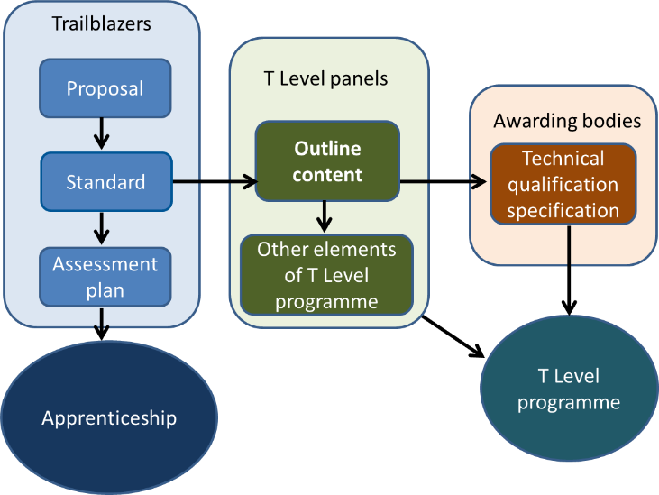
Colleges and other education and training providers will decide how to structure the T Level courses they offer, based on the qualification specifications. This will enable them to deliver the study programme’s mandatory components in the most effective way for students.
T Level study programmes will include the following mandatory elements:
- a ‘core’ set of underpinning knowledge, concepts and skills, tailored for their chosen industry and occupation: ‘core content’
- specialist training covering occupational or industry-specific skills: ‘occupational specialist content’
- an industry placement with an employer, which will last for a minimum of 45 working days.

The diagram below demonstrates the different elements of a T Level programme. This outline content relates solely to the Technical Qualification part of a T Level programme.

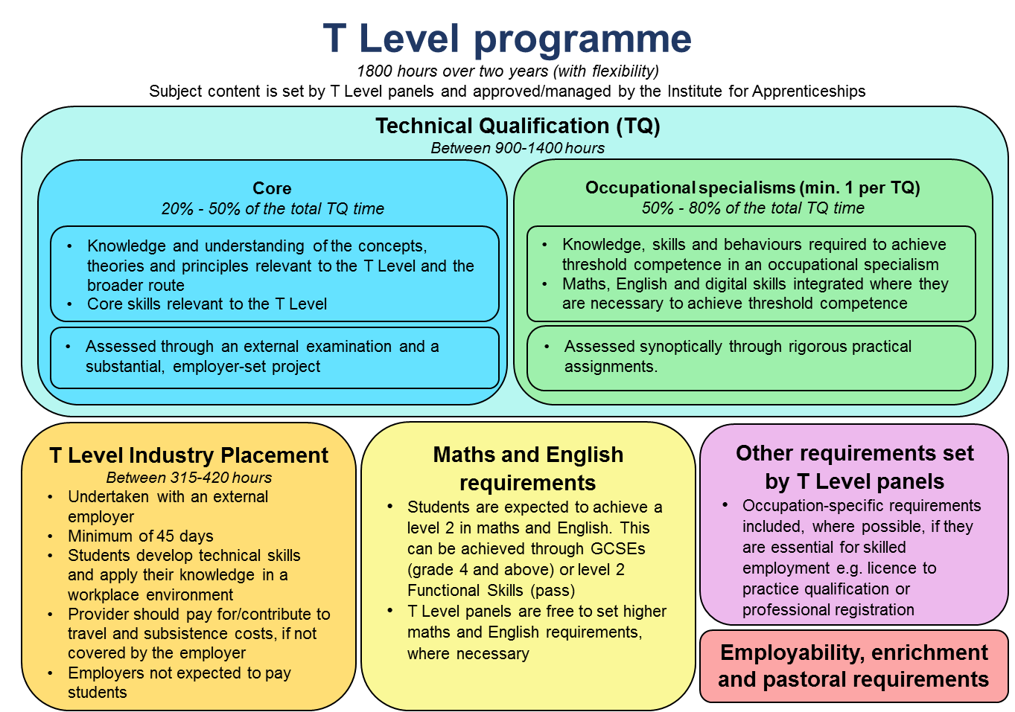

Purpose Statement
Qualification Purpose
The purpose of the level 3 Technical Qualification is to ensure students have the knowledge and skills needed to progress into skilled employment or higher level technical training relevant to the T Level.
To achieve this, each level 3 Technical Qualification must:
- provide reliable evidence of students’ attainment in relation to:
- the core knowledge and skills relevant to the route and occupational
specialisms covered by the qualification
- the knowledge and skills required for at least one occupational specialism relevant to the qualification.

- be up-to-date, providing the knowledge and skills needed for the
occupations to have continued currency among employers and others.

- ensure that maths, English and digital skills are developed and applied where they are essential to achieve occupationally relevant outcomes.

- ensure that the minimum pass grade standard for occupational specialisms attests to threshold competence, meets employer expectations, and is as close to full
occupational competence as possible.

- allow the accurate identification of students’ level of attainment and the effective differentiation of their performance.

- provide a clear and coherent basis for development of suitably demanding high-quality level 3 courses, which enable students to realise their potential.

- provide students with the opportunity to manage and improve their own
performance.

- support fair access to attainment for all students who take the qualification, including those with special educational needs and disabilities (SEND).

Technical Qualification Design
T Level programmes will differ in length to reflect the requirements of different occupations, but are expected to last 1800 hours over two years (on average).
To accommodate legitimate differences in content across T Levels, we propose that the total time for the Technical Qualification:
- will fall within a defined range of between 900 and 1400 hours
- is no less than 50% of the time for the T Level programme as a whole and
- is no more than 75% of the total time for the programme as a whole.

Component | Content | Assessment | Grading | Planned Hours
Core  Students complete one component which covers all the core content | Knowledge and understanding of contexts, concepts, theories and principles relevant to the T Level  Ability to apply core knowledge and skills, through a project, to meet employer-set requirements | Assessed through an externally set test and an employer-set project | Six point scale plus ungraded (U)  A* – E and U | Between 20% and 50% of the qualification time
Occupational specialisms  Students must complete at least one, or more depending on the minimum requirements specific to the qualification | The knowledge and skills needed to achieve threshold competence | Synoptic assessment of performance outcomes, to determine whether a student meets the minimum requirements for threshold competence | Three point scale plus ungraded (U)  Distinction, Merit, Pass and Ungraded | Between 50% and 80% of qualification time

Digital: Digital Production, Design and Development
This outline content includes reference to specific digital applications, software and platforms, though it is anticipated that these would require frequent updates to reflect technical developments. They have been included in this document in italics for easy identification.
Awarding organisations will need to ensure that students have an up-to-date knowledge of the legal and regulatory obligations relating to employment in the occupations relevant to the T Level, and understand the practical implication of these on their work.
Core content
The core content relates to the whole route, and the pathway that the Technical Qualification covers. This content will vary depending on the requirements of the route and the pathway or occupations covered by the scope of the Technical Qualification.
The core content focuses on students’ knowledge and understanding of contexts, concepts, theories, principles and core skills relevant to the T Level. This could include, where appropriate, assessment of knowledge, understanding and skills relevant to the route and the pathway. This breadth of content will help to ensure students are able to apply their skills in a variety of contexts and for a variety of different purposes.
The core content is assessed through an examination and a practical employer-set project. Awarding organisations can integrate knowledge in the employer-set project, to contextualise core skills. The allocation of content to each type of assessment will need to be approved by the Institute for Apprenticeships.
Core knowledge and understanding
Element | Content
Business Context | The business environment, including the importance of serving customer, end user and business needs, such as, customers, competitors, suppliers, government; and the social, political, legal and technological factors.  The value of Digital to the business:  - the value of the service to the customer and users  - measurable value of the service to growing the business  - processes and business models  - context and market environment.  Technical change management including:  - risk  - impact  - configuration  - document  - request for change  - roll back planning  - reproducibility  - traceability.  Examples of how organisations respond to change, why change is needed, and change management procedures, such as, New Driver Licensing Online System, NHS e-Referral Service (e-RS), Crown court digital case system, AI banking solutions provided by traditional banking services preparing for change, managing change and reinforcing change, relevant to Digital in a range of contexts:  - legal  - regulatory  - political  - economic  - social  - technological  - environmental  Understand the significance of customer needs, including:  - customer issues  - pain points  - business value  - brand awareness  - cultural awareness/ diversity  - accessibility  - internal/ external audience  - level of technical knowledge  - profile  Understand the risks in business context, including:  - privacy  - non-compliance  - audience exclusion  - resilience  - security  Examples of codes of conduct, implications of hacking and non-compliance, a working understanding of putting values into practice, e.g. Google code of conduct.
Culture | Ethical and moral issues that an increasing reliance on technology raises e.g. impact on company culture, autonomous operation, changing behaviours, addiction.
Data | Concepts and fundamentals of data, including:  - search, store, integrate and organise (e.g. index)  - how organisations of various types use data such as analysis of data to reveal trends and patterns and make recommendations for the future  - key features and functions of information systems, e.g. input, storage, processing, output and feedback loop  - data formats and their importance for analysis e.g. an understanding of file based and directory based structures  - entry and maintenance e.g. online data entry taking into consideration the types of data, research population, risk of data entry errors, research processes, privacy, regulations and the necessary time investment for both the creation of the entry screen as well as the data entry.  - visualisation and presentation i.e. graphs, pie charts, data table and infographics  - data modelling, e.g. hierarchical database model, relational model and network model  - How to manage and access data across different platforms, such as physical access, API
Digital Analysis | An understanding of Algorithms, and how they work using a step-by-step solution to a problem, or rules to follow to solve the problem  An understanding of Abstraction such as how to filter details, focusing on the important information only  An understanding of Action such as sequence, selection and iteration  An understanding of Decomposition such as breaking down a complex problem or system into smaller, more manageable parts  An understanding of Pattern recognition such as looking for similarities among and within problems
Digital Environments | Computing systems fundamentals including physical, virtual and cloud.  An understanding of the landscape of:  - network connectivity  - resilience of the environment  - physical systems: including hardware, peripherals, operating software, software  - an understanding of devices, servers, Internet of Things  - an understanding of networking fundamentals such as the hardware and protocols used to create networks  Cloud:  - an understanding of Terminology such as cloud portability and cloud sourcing  - an understanding of concepts such as SaaS (Software as a Service, PaaS (platform as a service) and IaaS (infrastructure as a Service)
Diversity and inclusion | The value of difference and being sensitive to the needs of others, especially when they are different from one’s own, this includes understanding the relevant legislation, such as the nine protected characteristics named in the Equality act 2010.
Learning | Be aware of emerging technology trends and innovation such as Internet of Things (IoT), Artificial Intelligence (AI), Augmented Reality (AR), Blockchain and 3D printing.  Application of learning techniques  - Reflection techniques such as Kolb and Gibbs or ‘doing, thinking, evaluating, analysing, concluding, action planning’  - The breadth of sources of knowledge reliable and unreliable e.g. internet and search engines, academic papers.  - Apply creativity e.g. design thinking
Legislation | The importance of keeping up with the most recent legislation, such as International law in cyberspace, International law and surveillance including professional practice, security standards, regulations and their consequences across at least two sectors; the role of criminal and other law; key relevant features of UK and international law such as international law in cyberspace, international law and surveillance  Legal and regulatory requirements e.g. Data Protection, Security, Intellectual Property Rights (IPR), Data sharing, marketing consent, personal data definition.  The role and importance of Industry Standards and where to find them (e.g. ISO standards, IETF RFCs).
Planning | The principles of planning including:  - cost  - cost benefit analysis  - dependencies  - people  - prioritisation  - quality  - time
Security | The importance of maintaining privacy and confidentiality of company information, as well as that of customers and colleagues, Such as not sharing information about salaries, employee perks, client lists, trade secrets, sales numbers, customer information, news about pending terminations, reasons for a firing, phone codes or computer passwords.  an understanding of Processes and protocols used to ensure internet security, including concepts of security assurance.  an understanding of Threats and vulnerabilities including the following areas:  - technical, such as Botnets, Distributed denial-of-service (DDoS), Hacking, Malware, Pharming, Phising, Ransomware, Spam.  - physical, Including vulnerabilities such as the characteristics and circumstances of a community, system or asset that make it susceptible to damaging effects.  - human such as human error, malicious employees and disguised criminals  The interrelationship between security, identity, confidentiality, integrity, availability, threat, vulnerability and risk management.
Testing | A fundamental understanding of the importance of testing for all components (including software, hardware, data), interfaces and the resulting service.  Application of root cause analysis to problems.  Concept testing  Usability (audience) testing
Tools | an understanding of Digital tools and their use in business:  - management and presentation tools such as presentation tools  - evaluation tools and techniques. such as project management tools  Examples of collaborative technologies:  - communication tools and technologies for collaborative working e.g. discussion threads, document collaboration, markdown.

Employer-set project
The employer-set project ensures students have the opportunity to combine core knowledge and skills to develop a substantial piece of work in response to an employer-set brief.

This employer set project is designed to be used in relation to Digital Production Design and Development.

To ensure consistency in project scope and demand, awarding organisations will develop assessment objectives, which require learners to:
- plan their approach to meeting the brief
- apply core knowledge and skills as appropriate
- select relevant techniques and resources to meet the brief
- use maths, English and digital skills as appropriate
- realise a project outcome and review how well the outcome meets the brief.

The awarding organisation will work with a relevant employer or employers, to devise a set brief that:
- ensures a motivating starting point for students’ projects, for example, a real-world problem to solve
- ensures students can generate evidence that covers the assessment objectives
- is manageable for providers to deliver
- is officially approved by the AO and employer.

For digital production design and development, in achieving the assessment objectives and meeting the brief, students must demonstrate the following core skills:

- reflective evaluation
- communicate information clearly to a technical and non-technical audience
- work with others in a collaborative manner to allow for/ encourage faster, better and more efficient achievement of goals
- develop software such as create software to operate a simple process to solve a problem
- create an artefact such as an app, website or data services
- apply a logical approach to solving problems, identifying and fixing defects and proposing software solutions
- ensure software development activity mitigates risks to security.

Occupational Specialist Content
Specialist content is structured into different occupational specialisms, which correspond to the apprenticeship standards listed on the occupational map covered by the T Level. Occupational specialisms ensure students develop the knowledge and skills necessary to achieve ‘threshold competence’ in the occupational specialism.
Achievement of threshold competence signals that a student is well placed to develop full occupational competence, with further support and development, once in work (including an apprenticeship). The knowledge and skills listed are required to achieve one or more ‘performance outcomes’. These indicate what the student will be able to do as a result of learning and applying the specified knowledge and skills.
In essence, each performance outcome describes, at a high level, what the student ‘can do’ to have achieved threshold competence in an occupational specialism.

Occupational Specialism: Digital Production, Design and Development
Performance Outcome 1: Analyse a problem to define requirements and acceptance criteria aligned to user needs
Knowledge Specific to Performance Outcome | Skills
Software Development Lifecycle (SDLC) Methodologies, including sequential and iterative, e.g. waterfall, Agile (Kanban, Scrum), eXtreme Programming, automated processes (continuous integration, continuous deployment, continuous delivery), DevOps  Software and business:  - measurable value of software as an asset in business  processes and business models e.g. purpose, efficiency, administration, compliance, competitive advantage, return on investment (ROI)  context and market environment e.g. awareness of current industry sectors (gaming, financial, health, logistics, manufacturing, agriculture, retail, public sector, telecomms) and how software is used; an awareness of emerging sectors and technologies (e.g. AI)  roles and responsibilities an understanding of technology and other areas of business that developers are likely to encounter e.g. product owner, project manager, Scrum master, audit, sales and marketing  Software requirements, including functional and non-functional.  an understanding of Analytical models e.g. how to identify and solve a problem (problem solving techniques, including use of models)  an understanding of Principles of problem analysis.  an understanding of User analysis, including the actors, the story, and their roles across the life of the software, development and use.  Acceptance criteria, including identification, value and use. | - Outline the business context and understand roles and responsibilities, such as products, roles and responsibilities of the digital team, how the team relates to the wider business.  Define a range of problems from the perspective of a user.  Define functional and non-functional requirements e.g. use cases, actors (people/systems), personas, storyboards, storycards, user stories  - Apply analytical decomposition and elicitation techniques, including algorithmic or functional, e.g. procedural languages, split a system into its constituent functions (activites, actions, processes, operations); and object-oriented split the system into discrete objects, with methods (functions) that can be applied to these objects.  Demonstrate how Key Performance Indicators (KPIs) can be used to frame and measure desired outcomes.  Develop and use acceptance criteria.  Identify and plan learning opportunities, such as reviewing own software development work and identifying any short comings by writing a commentary on their own digital ‘production’/artefact and say how it would be improved

Performance Outcome 2: Design, implement and test software

Knowledge Specific to Performance Outcome | Skills
Design:  - an understanding of architecture and design including tools, models, patterns and standards e.g. patterns of enterprise, gang of four  - An understanding of cultural awareness and diversity, e.g. Timezones and localisation, including Calendars, date and number formats, daylight saving, leap seconds  - self-documenting code, including purpose and structure  - interface design, including User and API  - an understanding of databases and database design  - an understanding of networks the interface between the software and the network, e.g. gaming  - an understanding of Platforms e.g. operating system, server, infrastructure, programming language stack, virtualisation, mobile, web  - an understanding of performance constraints e.g. network bandwidth, processor limitations  - an understanding of data dictionary/library e.g. data types for currency, decimal, floating point, signed/unsigned integers, big and little endian numbers, lists, stacks, maps  - an understanding of data types and structures.  Implement:  - development tools including version control e.g. git, IDEs, code coverage, fuzzers  - Understanding the workflow e.g. issue tracking  - code structure including singular purpose  - management and presentation tools e.g. dashboards, graphing, data presentation  - principles of object oriented, prototype-orientated e.g. functional languages, shell scripting e.g. POSIX or PowerShell  - a range of languages e.g. Java, C#, prototype-orientated e.g. Javascript or Lua  - code review  - deployment  - scalability, availability, reliability.  Test:  - fundamental principles of testing in the SDLC, test levels and test process e.g. happy path/sad path  - Usability testing  - debugging vs. testing and test first  - test types, including functional, non-functional, structural, change-related and regression  - static testing and reviews test-driven development (TDD), behaviour –driven development (BDD), acceptance test-driven development (ATDD)  - Test Techniques including Black Box and White Box  - Test Management, including strategy, approach, planning, control and risk management  - an understanding of Test Tool types and uses  - an understanding of defect management  - an understanding of quality assurance. | Implement secure code in at least two appropriate languages of different types which is maintainable, readable, functional.  Design software solutions to meet a requirement using tools and techniques, such as waterfall and agile  Demonstrate how to work in a shared codebase, practice, etiquette, tools, such as modularity, data definition  Use code organisation techniques, including classes, methods, sub-routines, re-factoring, open source, functions, modules and for e.g. checking small commits frequently  Integrate code which meets the functionality of the task, complies with the required standards and includes appropriate code documentation.  Implement systems including User Interface, Database, Service, Persistence, Web, Simple, Layered systems  Apply testing principles, types, techniques and tools to ensure that software meets specified requirements and can successfully operate in all the anticipated environments with the required usability and security.  Use simple debugging techniques, such as interactive debugging, print debugging, remote debugging  Perform code reviews, such as pair programming, informal walkthroughs, and formal inspections to find mistakes and improve the overall quality of software.  Write a test, describing the scope, approach, resources and schedule of intended test activities to clarify what needs to be done to test a system  Implement a test plan to show that a test plan is implementable in practice and implementation conforms to the plan.  Demonstrate observing techniques such as field observation and contextual enquiry  Apply a range of recording techniques e.g. product, problem, knowledge.  Use a range of communication techniques by adapting style and tone e.g. with the user, technical and non-technical (storyboard).

Performance Outcome 3: Change, maintain and support software
Knowledge Specific to Performance Outcome | Skills
Change:  - why change is needed, e.g. regulatory, review, test  - change requirements and the implications on the code e.g. risk  - communication methods and formats e.g. updates, functionality change, technical and non-technical  - understand software specific release management concepts at all stages, such as planning, scheduling and controlling a software build through different stages and environments; including testing and deploying software releases.  Software maintenance:  - maintainable code e.g. code that can be read, is not cryptic or obscure and is well commented or obvious  - types of maintenance e.g. planned and reactive, understanding relevance and impact of frequency  Support:  - the need for support in a changing technical and business environment e.g. bug fixes  - an understanding of causes of software issues  - an understanding communication methods including how to appropriately communicate about what has been done and why, the importance and the impact on others e.g. face to face, verbal and written (blog posts, video user training, release notes, FAQs, machine readable API contracts)  - audience e.g. technical and non -technical, internal and external.  Root cause analysis, e.g. the need to dig deeper than the symptoms, traceability and pattern analysis including lessons learned, issue tracking, incident and problem management | Communicate change, taking account of audience, frequency, timing and channels.  Follow a change process e.g. implications on code, analysis of requirements, communication process.  Add a feature and fix a bug in an unfamiliar application, whilst ensuring maintainability.  Test software as part of the maintenance cycle using techniques such as regression testing.  Identify the cause of a problem to restore service as soon as possible e.g. user error  Identify the causes of a software issue, e.g. system error, application error, resolving and reporting that may otherwise impair the progress of a project.  Refactor code without changing its behaviour.

Performance Outcome 4: Create solutions in a social and collaborative environment
Knowledge Specific to Performance Outcome | Skills
Collaborative technologies:  - collaboration tools and technologies, for collaborative working allowing for better communication, collaboration and cooperation among and between co-workers, e.g. discussion threads, document collaboration, markdown  - code collaboration technologies and how they improve code quality in software development, e.g. version control, source control, Integrated Development Environments (IDEs). | Use collaboration tools and technologies for source and version control to enable working together on common projects, regardless of physical location, e.g. BlueJeans, Broadview, Network Office Suite, and Cisco WebEx.  Use collaboration tools and technologies for writing technical documentation for, and adapting to, specific audience(s). e.g. technical, non-technical, internal, external  Use a range of communication styles, e.g. adapting to audience and environment, relevant communication preferences and needs

Performance Outcome 5: Discover, evaluate and apply reliable sources of knowledge
Knowledge Specific to Performance Outcome | Skills
Sources of knowledge:  - reliable and unreliable  e.g. internet and search engines, academic papers and peers.  Evaluation techniques, e.g. sources for code reuse unless contravening a licence  Communication methods e.g. code comments, commit messages and forums. | Identify (up to three) reliable sources, and assess their reliability, such as Google, stack overflow, Wikipedia,  Demonstrate the validity and appropriateness of the information and its legitimate use.  Corroborate across multiple sources e.g. cross referencing  Search for information relevant to a topic or scenarios, e.g. explore the future of the digital economy, identify trends in Big Data and key digital action initiatives using various future scenarios, to establish the scope of digital opportunities, a variety of digital channels  Select and use techniques and tools to aid evaluation, e.g. formative, summative, observation, user diaries, conclusions, and recommendations  Compare options, appraise and recommend actions to ensure reliability of source.  Identify and understand bias e.g. materials written by a particular developer such as Microsoft in the context of software development  Demonstrate critical thinking e.g. triangulation /evaluation of sources to make the best use of digital technologies.

Performance Outcome 6: Apply ethical principles and manage risks in line with legal and regulatory requirements when developing software
Knowledge Specific to Performance Outcome | Skills
Legal and regulatory requirements that apply to software development e.g. data protection, security, Intellectual Property Rights (IPR):  - software rights, copyrights and patent.  Standards and where to find them e.g. ISO standards, IETF RFCs,  e.g. UK, Europe, USA and the rest of the world  e.g. Distribution rights and licencing, Financial market regulations, PEGI ratings for gaming, cultural and legal considerations and restrictions  Principles of risk management, including identification, quantification and mitigation of risks.  Ethical implications that apply to software engineering e.g. hijacking code, software licensing e.g. GNU Public License (GPL), Creative Commons and End User License Agreements (EULA)  Codes of conduct, implications of hacking and non-compliance such as heavy fines and imprisonment  Ethical and moral issues that are raised by increasing reliance on technology e.g. autonomous operation, changing behaviours, addiction  Different means of attack on a business through different vectors, e.g. software and social.  Dangers and losses that may occur both to organisations and individuals through attacks, through denial of service and theft of personal information. | Source regulatory and legal information and territorial restrictions in relation to software development.  Check for the existence of and follow guidelines or rules that underpin regulations.  Identify, quantify and mitigate risks using a basic framework e.g. a risk register, risk scores, likelihood impact and heat maps  Adhere to codes of conduct in a community, and recognise inappropriate behaviour.  Demonstrate methods to reduce the risk and impact of attack, such as a business continuity plan, policies for use of company equipment and bring your own device  Apply and maintain procedures and security controls to ensure confidentiality, integrity and availability.  Apply information law in the use of client data e.g. not using personally identifiable information in test systems, making sure personal actions comply with ICO regulations.  Use a range of observational techniques to inform situational awareness including whistle blowing, mindfulness, observing normal behaviour, awareness of co-workers and recognising changing or abnormal behaviour

Maths, English and digital skills

Maths
The completion of a level 2 mathematics qualification (GCSE mathematics or Functional Skills) is a minimum exit requirement for all T Levels. This will ensure that all students have demonstrated fluency and competence in mathematics, and are able to recognise the importance of mathematics in their own lives, in work and to society. Achievement of a level 2 mathematics qualification will also provide the foundation to access mathematics at a higher level, if required.

Technical Qualifications should contain sufficient and appropriate maths to help students reach threshold competence in their chosen specialism(s). The following General Maths Competencies (GMCs) have been developed with input from the Royal Society Advisory Committee on Maths Education (ACME), and awarding organisations will need to embed these, and the underpinning maths, into the specifications and assessments being developed as part of the Technical Qualification.

The GMCs below are relevant to this particular Technical Qualification:
- Communicate using mathematics
- Estimate, calculate and error-spot
- Optimise work processes
- Process data
- Represent with mathematical diagrams
- Understand data
- Use rules and formulae
- Work with proportion.

Awarding organisations who are awarded an exclusive license will need to integrate these into the Technical Qualification specifications and assessments, drawing upon a more detailed framework of maths that underpins the GMCs, currently being developed in association with the Royal Society ACME.

English
The completion of a level 2 English qualification (English language GCSE or Functional Skills) is a minimum exit requirement for all T Levels. This will ensure that all students have demonstrated that they can read fluently, communicate and write effectively, and demonstrate a confident control of Standard English.

The specifications for Technical Qualifications should ensure that students acquire the technical vocabulary, and gain the practical communication skills (written and oral), needed to achieve threshold competence in their chosen occupational specialism(s).

The assessments for Technical Qualifications should ensure that students:
- Know the correct technical vocabulary and use it appropriately
- Apply their communication skills (written and oral) appropriately, using Standard English
- Use accurate spelling, punctuation and grammar.

Digital
Technical Qualifications should contain sufficient and appropriate digital skills to help students reach threshold competence in their chosen specialism(s).

This Technical Qualification should support students to develop the digital knowledge and skills needed in order to:
- Act safely and responsibly in digital environments
- Develop and project a positive digital identity and manage digital reputation
- Adopt professional approaches to using digital communications and social media
- Be aware of information security and the security controls that can be used to mitigate security threats within solutions and services
- Boolean and set operations (AND OR and NOT)
- Follow licensing guidelines, using only approved and licensed software applications
- Choose devices, applications, software and systems relevant to different tasks, having assessed their benefits and constraints
- Collate, manage, access and use digital data in spreadsheets, databases and other formats, and interpret data by running queries, data analyses and reports
- Qualify information sources, evaluating their reliability and suitability for a purpose
- Share information securely
- Take a critical approach to evaluating information in terms of its provenance, relevance, value and credibility
- Understand and apply appropriate accessibility requirements e.g. W3C
- Understand digital media as a social, political and educational tool, and of digital media production as a technical practice
- Understand digital research methods and data analysis tools and techniques
- Understand how data is used in professional and public life
- Understand innovation, enterprise and project management in digital settings
- Understand the benefits and risks involved in digital participation
- Understand the rules of copyright and open alternatives e.g. creative commons, and reference digital works appropriately in digital contexts
- Use business etiquette when communicating
- Use digital evidence to solve problems and answer questions
- Using rules and formulae (Boolean search criteria).
Awarding organisations who are awarded an exclusive license will need to integrate these into the Technical Qualification specifications and assessments.

The Institute for Apprenticeships may only approve the qualification “if satisfied that by obtaining the qualification a person demonstrates that he or she has attained as many of the outcomes set out in the standards as may reasonably be expected to be attained by undertaking a course of education” (sA2DA(3) of the 2009 Act).

