Digital:
Digital Business Services
T Level outline content: final version for approval
December 2018

Contents
Introduction | 3
Outline content for T Levels:
Core Content | 8
Employer-set project | 12
Occupational specialist content:  - Data Technician  English, Maths and Digital Skills | 13  22

Introduction
T Levels are new, two-year, technical study programmes, designed with employers to give young people the skills that industry needs. T Levels will provide a mixture of:
- technical knowledge and skills specific to their chosen industry or occupation
- an industry placement of at least 45 days in their chosen industry or occupation
- relevant maths, English and digital skills.
T Levels will become one of three major options for students to study at level 3, alongside apprenticeships for those who wish to study and train for a specific occupation ‘on the job’, and A levels for students who wish to continue academic education.
When they complete a T Level study programme, students will be able to choose between moving into a skilled occupation or further study, for example, a higher or degree level apprenticeship, or higher level technical study, including higher education.
Technical education has been categorised into fifteen different technical routes, according to occupational specialism. T Levels will be available across eleven of those routes, with occupations in the remaining four routes accessible through an apprenticeship only. Most routes have been split into a number of pathways; the T Level will broadly sit at pathway level. The occupations within scope for each T Level are set out in the Institute for Apprenticeships’ occupational maps.

Outline content

This outline content has been produced by T Level panels of employers, professional bodies and providers, and is based on the same standards as those used for apprenticeships. The outline content will form the basis of the specifications for T Level Technical Qualifications, which will be developed by awarding organisations for approval by the Institute for Apprenticeships. One awarding organisation will be appointed to develop and deliver each Technical Qualification following a procurement process.

The diagram below demonstrates how the same standard created by employer-led Trailblazer groups is used for both apprenticeships, and as the basis for this outline content. It also shows that this outline content will be used by awarding organisations to develop the full Technical Qualification specification.

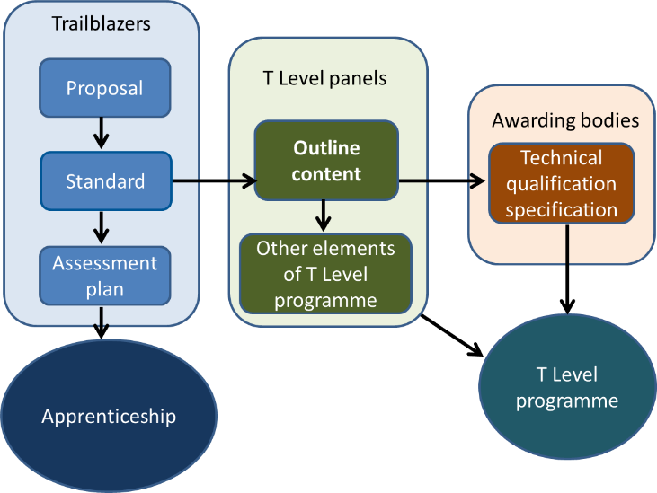
Colleges and other education and training providers will decide how to structure the T Level courses they offer, based on the qualification specifications. This will enable them to deliver the study programme’s mandatory components in the most effective way for students.
T Level study programmes will include the following mandatory elements:
- a ‘core’ set of underpinning knowledge, concepts and skills, tailored for their chosen industry and occupation: ‘core content’
- specialist training covering occupational or industry-specific skills: ‘occupational specialist content’
- an industry placement with an employer, which will last for a minimum of 45 working days.

The diagram below demonstrates the different elements of a T Level programme. This outline content relates solely to the Technical Qualification part of a T Level programme.

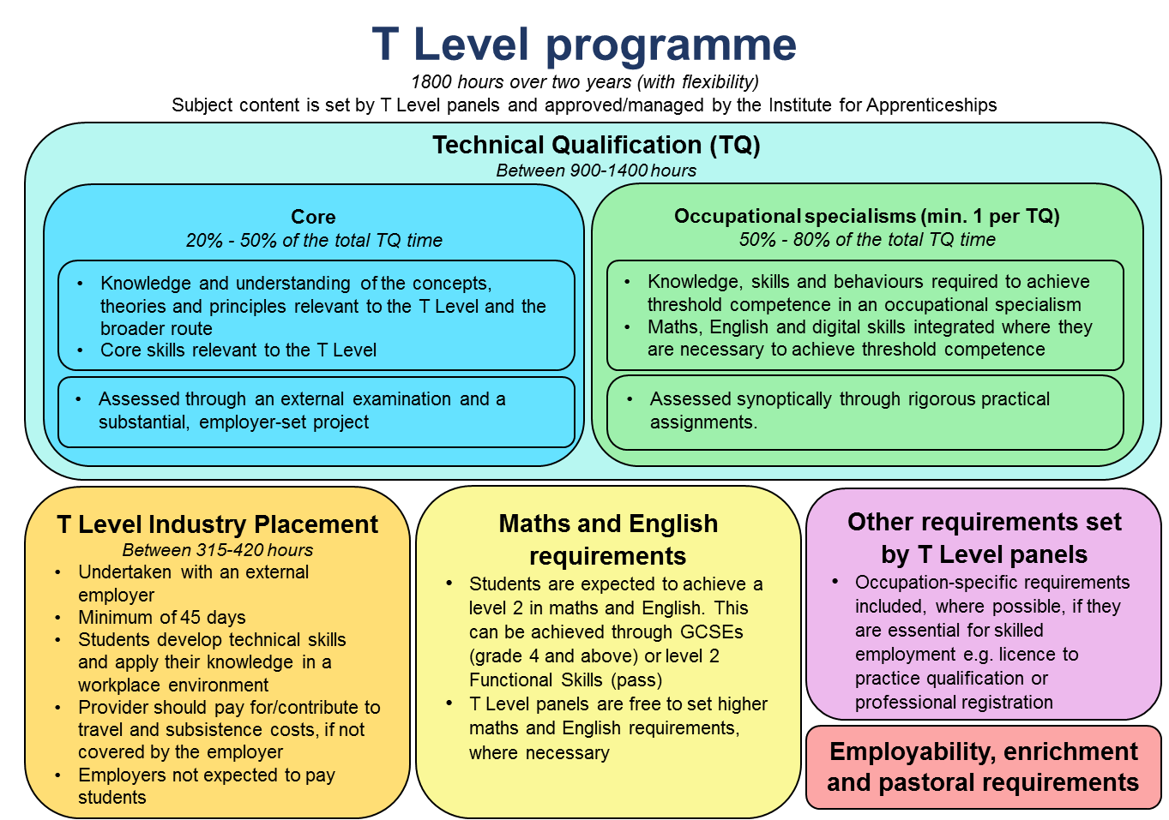

Purpose Statement
Qualification Purpose
The purpose of the level 3 Technical Qualification is to ensure students have the knowledge and skills needed to progress into skilled employment or higher level technical training relevant to the T Level.
To achieve this, each level 3 Technical Qualification must:
- provide reliable evidence of students’ attainment in relation to:
- the core knowledge and skills relevant to the route and occupational
specialisms covered by the qualification
- the knowledge and skills required for at least one occupational specialism relevant to the qualification.

- be up-to-date, providing the knowledge and skills needed for the
occupations have continued currency among employers and others.

- ensure that maths, English and digital skills are developed and applied where they are essential to achieve occupationally relevant outcomes.

- ensure that the minimum pass grade standard for occupational specialisms attests to threshold competence, meets employer expectations, and is as close to full
occupational competence as possible.

- allow the accurate identification of students’ level of attainment and the effective differentiation of their performance.

- provide a clear and coherent basis for development of suitably demanding high-quality level 3 courses, which enable students to realise their potential.

- provide students with the opportunity to manage and improve their own
performance.

- support fair access to attainment for all students who take the qualification, including those with special educational needs and disabilities (SEND).

Technical Qualification Design
T Level programmes will differ in length to reflect the requirements of different occupations, but are expected to last 1800 hours over two years (on average).
To accommodate legitimate differences in content across T Levels, we propose that the total time for the Technical Qualification:
- will fall within a defined range of between 900 and 1400 hours
- is no less than 50% of the time for the T Level programme as a whole and
- is no more than 75% of the total time for the programme as a whole.

Component | Content | Assessment | Grading | Planned Hours
Core  Students complete one component which covers all the core content | Knowledge and understanding of contexts, concepts, theories and principles relevant to the T Level  Ability to apply core knowledge and skills, through a project, to meet employer-set requirements | Assessed through an externally set test and an employer-set project | Six point scale plus ungraded (U)  A* – E and U | Between 20% and 50% of the qualification time
Occupational specialisms  Students must complete at least one, or more depending on the minimum requirements specific to the qualification | Knowledge and skills needed to achieve threshold competence | Synoptic assessment of performance outcomes, to determine whether a student meets the minimum requirements for threshold competence | Three point scale plus ungraded (U)  Distinction, Merit, Pass and Ungraded | Between 50% and 80% of qualification time

Digital: Digital Business Services
This outline content includes reference to specific digital applications, software and platforms, though it is anticipated that these would require frequent updates to reflect technical developments. They have been included in this document in italics for easy identification.
Awarding organisations will need to ensure that students have an up-to-date knowledge of the legal and regulatory obligations relating to employment in the occupations relevant to the T Level and understand the practical implication of these on their work.
Maths, English and digital skills are set out in the final section of this document. Awarding organisations should integrate these within the qualification so that they are applied in occupationally relevant contexts. Other core skills and behaviours important for employability are already integrated within the content and must be clearly specified in the qualification specification.

Core content
The core content relates to the whole route, and the pathway that the Technical Qualification covers. This breadth of content will help to ensure students are able to apply their skills in a variety of contexts and for a variety of different purposes. The content will vary depending on the requirements of the route and the pathway or occupations covered by the scope of the qualification.
The core knowledge and understanding is assessed through an examination and core skills through a practical employer-set project.
The core knowledge and understanding focuses on the students’ knowledge and understanding of contexts, concepts, theories and principles relevant to the T Level. This could include, where appropriate, assessment of knowledge and understanding relevant to the route and the pathway.
The employer-set project provides the opportunity to develop and apply a minimum range of core skills important for employability. Awarding organisations can integrate knowledge in the employer-set project, to contextualise core skills.
The allocation of content to each type of assessment will need to be approved by the Institute for Apprenticeships.

Core Knowledge and Understanding
Element | Content
Business Context | The business environment, including the importance of serving customer, end user and business needs, such as, customers, competitors, suppliers, government; and the social, political, legal and technological factors.  The value of Digital to the business:  - the value of the service to the customer and users  - measurable value of the service to growing the business  - processes and business models  - context and market environment.  Technical change management including:  - risk  - impact  - configuration  - document  - request for change  - roll back planning  - reproducibility  - traceability.  Examples of how organisations respond to change, why change is needed, and change management procedures, such as, New Driver Licensing Online System, NHS e-Referral Service (e-RS), Crown court digital case system, AI banking solutions provided by traditional banking services preparing for change, managing change and reinforcing change, relevant to Digital in a range of contexts:  - legal  - regulatory  - political  - economic  - social  - technological  - environmental.  Understand the significance of customer needs, including:  - customer issues  - pain points  - business value  - brand awareness  - cultural awareness/ diversity  - accessibility  - internal/ external audience  - level of technical knowledge  - profile.  Understand the risks in business context, including:  - privacy  - non-compliance  - audience exclusion  - resilience  - security.  Examples of codes of conduct, implications of hacking and non-compliance, a working understanding of putting values into practice, e.g. Google code of conduct.
Culture | Ethical and moral issues that an increasing reliance on technology raises e.g. impact on company culture, autonomous operation, changing behaviours, addiction.
Data | Concepts and fundamentals of data, including:  - search, store, integrate and organise (e.g. index)  - how organisations of various types use data such as analysis of data to reveal trends and patterns and make recommendations for the future  - key features and functions of information systems e.g. input, storage, processing, output and feedback loop  - data formats and their importance for analysis e.g. an understanding of file based and directory based structures  - entry and maintenance e.g. online data entry taking into consideration the types of data, research population, risk of data entry errors, research processes, privacy, regulations and the necessary time investment for both the creation of the entry screen as well as the data entry  - visualisation and presentation i.e. graphs, pie charts, data table and infographics  - data modelling e.g. hierarchical database model, relational model and network model  - How to manage and access data across different platforms, such as physical access, API.
Digital Analysis | An understanding of Algorithms, and how they work using a step-by-step solution to a problem, or rules to follow to solve the problem  An understanding of Abstraction such as how to filter details, focusing on the important information only  An understanding of Action such as sequence, selection and iteration  An understanding of Decomposition such as breaking down a complex problem or system into smaller, more manageable parts  An understanding of Pattern recognition such as looking for similarities among and within problems
Digital Environments | Computing systems fundamentals including physical, virtual and cloud.  An understanding of the landscape of:  - network connectivity  - resilience of the environment  - physical systems: including hardware, peripherals, operating software, software  - an understanding of devices, servers, Internet of Things  - an understanding of networking fundamentals such as the hardware and protocols used to create networks.  Cloud:  - an understanding of Terminology such as cloud portability and cloud sourcing  - an understanding of concepts such as SaaS (Software as a Service, PaaS (platform as a service) and IaaS (infrastructure as a Service).
Diversity and inclusion | The value of difference and being sensitive to the needs of others, especially when they are different from one’s own, this includes understanding the relevant legislation, such as the nine protected characteristics named in the Equality act 2010.
Learning | Be aware of emerging technology trends and innovation such as Internet of Things (IoT), Artificial Intelligence (AI), Augmented Reality (AR), Blockchain and 3D printing.  Application of learning techniques  - Reflection techniques such as Kolb and Gibbs or ‘doing, thinking, evaluating, analysing, concluding, action planning’  - The breadth of sources of knowledge reliable and unreliable e.g. internet and search engines, academic papers  - Apply creativity e.g. design thinking.
Legislation | The importance of keeping up with the most recent legislation, such as International law in cyberspace, International law and surveillance including professional practice, security standards, regulations and their consequences across at least two sectors; the role of criminal and other law; key relevant features of UK and international law such as international law in cyberspace, international law and surveillance  Legal and regulatory requirements e.g. Data Protection, Security, Intellectual Property Rights (IPR), Data sharing, marketing consent, personal data definition  The role and importance of Industry Standards and where to find them (e.g. ISO standards, IETF RFCs)
Planning | The principles of planning including:  - cost  - cost benefit analysis  - dependencies  - people  - prioritisation  - quality  - time.
Security | The importance of maintaining privacy and confidentiality of company information, as well as that of customers and colleagues, such as not sharing information about salaries, employee perks, client lists, trade secrets, sales numbers, customer information, news about pending terminations, reasons for a firing, phone codes or computer passwords  An understanding of Processes and protocols used to ensure internet security, including concepts of security assurance  An understanding of Threats and vulnerabilities including the following areas:  - technical, such as Botnets, Distributed denial-of-service (DDoS), Hacking, Malware, Pharming, Phishing, Ransomware, Spam  - physical, including vulnerabilities such as the characteristics and circumstances of a community, system or asset that make it susceptible to damaging effects  - human such as human error, malicious employees and disguised criminals.  The interrelationship between security, identity, confidentiality, integrity, availability, threat, vulnerability and risk management.
Testing | A fundamental understanding of the importance of testing for all components (including software, hardware, data), interfaces and the resulting service  Application of root cause analysis to problems  Concept testing  Usability (audience) testing
Tools | An understanding of Digital tools and their use in business:  - management and presentation tools such as presentation tools  - evaluation tools and techniques. such as project management tools  Examples of collaborative technologies:  - communication tools and technologies for collaborative working e.g. discussion threads, document collaboration, markdown.

Employer-set project
The employer-set project ensures students have the opportunity to combine core knowledge and skills to develop a substantial piece of work in response to an employer-set brief.

To ensure consistency in project scope and demand, awarding organisations will develop assessment objectives, which require learners to:
- plan their approach to meeting the brief
- apply core knowledge and skills as appropriate
- select relevant techniques and resources to meet the brief
- use maths, English and digital skills as appropriate
- realise a project outcome and review how well the outcome meets the brief.

The awarding organisation will work with a relevant employer or employers, to devise a set brief that:
- ensures a motivating starting point for students’ projects, for example, a real-world problem to solve
- ensures students can generate evidence that covers the assessment objectives
- is manageable for providers to deliver
- is officially approved by the awarding organisation and employer.

For Digital Business Services, in achieving the assessment objectives and meeting the brief, students must demonstrate the following core skills:

- work with stakeholders to clarify and consider options to meet requirements
- investigate, for example
  - identifying sources, developing search criteria/queries, interrogating data, designing and carrying out tests
- apply a logical approach to solving data problems, identifying and resolving issues whilst recording progress and solutions
- ensure activity identifies and avoids risks to security
- communicate information clearly to a technical and non-technical audience
- reflective evaluation and the importance of continuous learning.

Occupational Specialist Content
Specialist content is structured into different occupational specialisms, which correspond to the apprenticeship standards listed on the occupational map covered by the T Level. Occupational specialisms ensure students develop the knowledge and skills necessary to achieve ‘threshold competence’ in the occupational specialism.
Achievement of threshold competence signals that a student is well-placed to develop full occupational competence, with further support and development, once in work (including an apprenticeship). The knowledge and skills listed are required to achieve one or more ‘performance outcomes’. These indicate what the student will be able to do as a result of learning and applying the specified knowledge and skills.
In essence, each performance outcome describes, at a high level, what the student ‘can do’ to have achieved threshold competence in an occupational specialism.
Core skills and behaviours are specified in occupational specialism(s) only where they are essential to achieving the given performance outcome. Although the behaviours may be assessed implicitly through application of skills, they must be clearly specified in the qualification specification to support effective application of those skills.

Occupational Specialism: Data technician
Performance Outcome 1: Source, organise and format data securely in a relevant way for analysis
Knowledge | Skills
Common sources of data:  - internal, data that is held in the business  - external, held by external organisations  - public, including government  - open, which is open source, or published as a government requirement  - private, including person identifiable and commercially sensitive data  Types, key features and functions of information systems in different types of organisations e.g. Health Information systems, Customer Management systems, Human Capital Management systems  Data Foundations:  Structures  - structured  - un-structured  - semi-structured  Types including their importance for calculations and data blending  - textural  - numeric including financial  - Boolean  - references  - temporal, date, time and duration  - geospatial  - imagery e.g. photographic, video, satellite  - audio  Data usage including:  - how individuals and organisations of various types use data e.g. individualised needs, customer centricity, business intelligence and forecasting, product design, organisational and staff development  - the difference between primary and secondary usage to ensure that processing is always carried out legitimately  - key features and functions of information systems including data storage, manipulation and retrieval  - data lifecycle management including creation, version control, storage, usage, exploitation, sharing, archiving, retention and destroying  Data Quality  - understand the range of common data quality issues that can arise including inaccurate or missing data, duplicates, different formats and mismatched types  - understand the importance of storing and classifying data in a way that enables understanding, appropriate use and ease of future analysis  - data confidence and the need for cleaning data to enable accurate and meaningful analysis and results e.g. is this likely to fall outside of tolerance thresholds  - an understanding of the importance of data audit to maintain data integrity  - the importance of dealing with missing data in a way that does not introduce bias e.g. missing regional data sets in a national study  - understand patterns that might indicate where there are errors in data and how to deal with them  Data architecture  - Understand the data architecture including structures, format, location, permissions and access requirements across different systems | Identify different sources of data to undertake the specified analysis  Collect data from different internal or external sources, including  - structured data e.g. spreadsheets and databases  - unstructured data e.g. social media posts, web, documents, imagery, audio visual  - semi-structured e.g. data computer system log file which needs manipulating into an easier-to-use format  Classify data for domain-specific applications such as medical, biological, scientific, marketing and operations  Organise and store sourced data securely in a specified format e.g. database, repository  Combine data from different sources into a single unified structure  Format different types of data e.g. same list from textual  Change data type to best fit the data to be analysed  Examine and recognise structural issues with data  Clean data using standard understood approaches including remove duplicates, typos, out of date data, parse data e.g. format telephone numbers according to a national standard  Validate and assess veracity of the data e.g. citing trusted sources, reconciling using multiple checks and ambiguities  Explain the appropriateness of the resultant data sets for the specified analysis  Provide a basic statistical summary to include relevant results e.g. regressions, trends, gains and derived data

Performance Outcome 2: Blend data from multiple sources
Knowledge | Skills
Data blending  - query based tools used for blending data e.g. macros in spreadsheets, SQL in databases, NoSQL  - common data blending techniques such as data joining, union data, fuzzy matching, spatial matching, consolidation  - an understanding of how to merge data from multiple sources  Data Operations  - data technologies and data systems  - database operations e.g. joining tables  - spreadsheet operations e.g. combining data across worksheets | Combine datasets in different formats  Perform data joining, union data, fuzzy match data, spatially match data to create a combined data set for a specified purpose  Design analytical workflows working with proprietary / on-premises or SaaS and analytic services  Blend data sets from multiple sources and present in a specified format  Design and set up a simple dataset  Import and export data from a dataset  Design and execute logical queries  Create spreadsheets including pivot tales  Analyse spreadsheets and datasets to identify data to be blended  Automate spreadsheet models using macros

Performance Outcome 3: Analyse structured and unstructured data to support business outcomes
Knowledge | Skills
Understand data analysis techniques to solve simple business problems e.g. identifying trends and patterns, forecasting, use of AI and machine learning  The value of data to business  - driving performance and outcomes including individual, team, organisation, societal  - business intelligence  - competitive advantage  - process improvement  Understand the process of how to solve a business problem using data e.g.  - discover  - investigate  - plan  - prioritise  - analyse  - test and reiterate if required  - report outcome  Principles of data preparation, analysis, modelling and testing | Perform the steps in the data process  - business understanding  - data understanding  - data preparation  - basic data analysis  - data validation  - visualisation e.g. dashboard, reports as appropriate  - data presentation e.g. walk-through of analysis, audio, video, reports  Identify data available, data characteristics and relevant data for the specified business problem  Gather, cleanse, format, blend iteratively until a completed data set is created  Build a dataset, test a dataset

Performance Outcome 4: Interpret data and communicate a result appropriate to the audience
Knowledge | Skills
Visualisation techniques and how to create e.g. graphical presentation, 3 D models, XR, maps, tables and select which techniques are appropriate for a particular audience or data set  Communication methods, formats and techniques, including:  - written, verbal, non-verbal  - presentation  - audience  - active listening | Undertake collaborative review to validate the results in the context of a business problem  Use a range of communication techniques demonstrating the ability to:  - listen  - reflect  - use a framework for conversation  - question  - develop a narrative  e.g. to review web and social media effectiveness through data analytics services used to visualise and present the results of web, email and social media sales and marketing projects  follow the different steps through which raw data becomes meaningful to be represented in graphics and presented visually for a business scenario  develop a specification in response to customer requirements and present that specification and the benefits to a non-technical panel  Write materials, demonstrating the ability to tell a story  Demonstrate value to the business by linking the communication of the data back to a specified business objective

Performance Outcome 5: Can apply legal, ethical and professional principles when manipulating data
Knowledge | Skills
Legal and regulatory requirements that apply to data analysis e.g. data protection, data security, Intellectual Property Rights (IPR)  Data sharing; code of practice  Data Standards and their application to different business contexts and where to find them  Principles of risk management, including identification, quantification and mitigation of risks when dealing with data  Ethical implications that apply to data analysis  Ethical and moral issues that are raised by increasing reliance on data and technology e.g. autonomous operation, changing behaviours, addiction  Different means of attack on a business through different vectors, e.g. cyber and social engineering  Dangers and losses that may occur both to organisations and individuals through attacks, through cyber attacks e.g. denial of service and theft of personal or commercial information e.g. GDPR penalties  Marketing consent e.g. PECR, GDPR and other relevant regulations  Personal identifiable data definition and how it relates to primary and secondary use e.g. consent and legal basis  Role of the Data Protection Officer e.g. data stewards, other data guardians and those who hold governance roles | Source regulatory and legal information in relation to data analysis e.g. territorial restrictions for the transfer of data (safe havens)  Check for the existence of and follow guidelines or rules that underpin regulations  Implement data (investigations, procedures, processes) in an informed and safe manner demonstrating what is permitted and what is not e.g. the ways in which patient data are being re-used for medical research  Identify, quantify and mitigate risks using a basic framework e.g. a risk register  Demonstrate understanding of methods to reduce the risk and impact of attack, such as a business continuity plan, policies for use of company equipment and bring your own device and e.g. identify privacy and security concerns in different contexts  Apply and maintain procedures and security controls to ensure confidentiality, integrity and availability e.g. pseudonymisation of patient data  Apply relevant regulations (e.g. GDPR) in the use of person identifiable data, making sure personal actions comply with regulations  Use a range of observational techniques to inform situational awareness and flag concerns around unethical behaviour

Performance Outcome 6: Discover, evaluate and apply reliable sources of knowledge
Knowledge Specific to Performance Outcome | Skills
Sources of knowledge:  - reliable and unreliable  e.g. internet and search engines, academic papers and peers  Evaluation techniques e.g. qualitative using interviews observation and workshops and quantitative using experiments, surveys and industry standard open data sharing platforms e.g. real time bus arrival, pharmacies and health outcomes  Communication methods e.g. visualisation, dashboard, audio visual on various channels, extended reality, cross channel engagement | Identify (up to three) sources, and assess their reliability, such as Google, open data sets, Wikipedia  Demonstrate the validity and appropriateness of the information and its legitimate use e.g.  - establish that sources are fit for purpose and mitigate conscious and unconscious bias in data and its veracity  - discern malicious data practises such as fake news  Corroborate across multiple sources e.g. cross referencing  Search for information relevant to a topic or scenarios e.g. explore the future of the digital economy, identify trends in Big Data and key digital action initiatives using various future scenarios, to establish the scope of digital opportunities, a variety of digital channels  Select and use techniques and tools to aid evaluation e.g. formative, summative, observation, user diaries, conclusions, reflections, deductions and recommendations  Compare options, appraise and recommend actions to ensure reliability of source  Identify and understand bias  - where datasets in use are not representative  - how data may exhibit biases and prejudice  - how bias is created and ways of avoiding bias  Demonstrate critical thinking e.g. triangulation /evaluation of sources to make the best use of digital technologies

Integrating maths, English and digital skills

Maths
The completion of a level 2 mathematics qualification (GCSE mathematics or Functional Skills) is a minimum exit requirement for all T Levels. This will ensure that all students have demonstrated fluency and competence in mathematics, and are able to recognise the importance of mathematics in their own lives, in work and to society. Achievement of a level 2 mathematics qualification will also provide the foundation to access mathematics at a higher level, if required.

Technical Qualifications should contain sufficient and appropriate maths to help students reach threshold competence in their chosen specialism(s). The following General Maths Competencies (GMCs) have been developed with input from the Royal Society Advisory Committee on Maths Education (ACME), and awarding organisations will need to embed these, and the underpinning maths, into the specifications and assessments being developed as part of the Technical Qualification.

The GMCs below are relevant to this particular Technical Qualification:
- Communicate using mathematics
- Estimate, calculate and error-spot
- Optimise work processes
- Process data
- Represent with mathematical diagrams
- Understand data
- Use rules and formulae
- Work with proportion.
Awarding organisations that are awarded an exclusive licence will need to integrate these into the Technical Qualification specification and assessments, drawing upon a more detailed framework of maths that underpins the GMCs, currently being developed in association with the Royal Society ACME.

English
The completion of a level 2 English qualification (English language GCSE or Functional Skills) is a minimum exit requirement for all T Levels. This will ensure that all students have demonstrated that they can read fluently, communicate and write effectively, and demonstrate a confident control of Standard English.

The specification for a Technical Qualification should ensure that students acquire the technical vocabulary, and gain the practical communication skills (written and oral), needed to achieve threshold competence in their chosen occupational specialism(s).

The assessments for Technical Qualifications should ensure that students:
- Know the correct technical vocabulary and use it appropriately
- Apply their communication skills (written and oral) appropriately, using Standard English
- Use accurate spelling, punctuation and grammar.

Digital
Technical Qualifications should contain sufficient and appropriate digital skills to help students reach threshold competence in their chosen specialism(s).

This Technical Qualification should support students to develop the digital knowledge and skills needed in order to:
- Act safely and responsibly in digital environments
- Develop and project a positive digital identity and manage digital reputation
- Adopt professional approaches to using digital communications and social media
- Be aware of information security and the security controls that can be used to mitigate security threats within solutions and services
- Boolean and set operations (AND OR and NOT)
- Follow licensing guidelines, using only approved and licensed software applications
- Choose devices, applications, software and systems relevant to different tasks, having assessed their benefits and constraints
- Collate, manage, access and use digital data in spreadsheets, databases and other formats, and interpret data by running queries, data analyses and reports
- Qualify information sources, evaluating their reliability and suitability for a purpose
- Share information securely
- Take a critical approach to evaluating information in terms of its provenance, relevance, value and credibility
- Understand and apply appropriate accessibility requirements e.g. W3C
- Understand digital media as a social, political and educational tool, and of digital media production as a technical practice
- Understand digital research methods and data analysis tools and techniques
- Understand how data is used in professional and public life
- Understand innovation, enterprise and project management in digital settings
- Understand the benefits and risks involved in digital participation
- Understand the rules of copyright and open alternatives e.g. creative commons, and reference digital works appropriately in digital contexts
- Use business etiquette when communicating
- Use digital evidence to solve problems and answer questions
- Using rules and formulae (Boolean search criteria).
Awarding organisations that are awarded an exclusive licence will need to integrate these into the Technical Qualification specification and assessments.

The Institute for Apprenticeships may only approve the qualification “if satisfied that by obtaining the qualification a person demonstrates that he or she has attained as many of the outcomes set out in the standards as may reasonably be expected to be attained by undertaking a course of education” (2017 Technical & Further Education Act).

